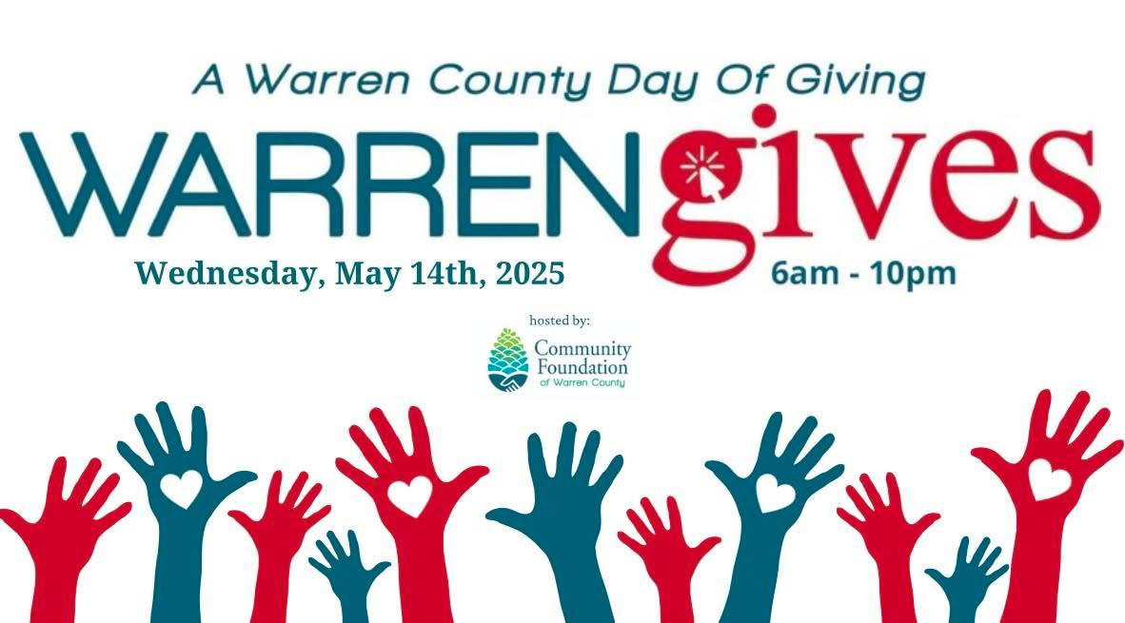

GARLAND VOLUNTEER FIRE DEPARTMENT

again, is participating in the

WARREN GIVES 2025 PROJECT

**2025 commemorates our service to the community for 70 years.**

The mission of the Garland Volunteer Fire Department is to provide a safe, professional and courteous team that strives to exceed our community’s expectations within our organization. This requires our members to be part of a capable, aggressive, all risk emergency service that focuses on

"**Preserving the Past and Protecting the Future**" of those we serve.

Current Project / Needs – As we progress into the year of 2025, our needs are for renovation of our facility. Our fire station and social hall are 30 years old, the current need for our facility is:

new entrance canopies and new flooring in our social hall.

Your contribution through Warren Gives will be put towards these projects.

You can donate to us by going to the

Serving the Community section at www.warrengives.org

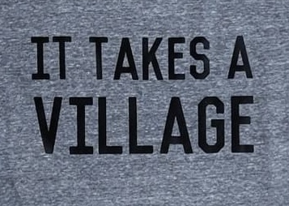and select

**Garland Volunteer Fire Department**

Contact: Ron Hodak

Phone: 814-688-8729

Email: hodie1060@yahoo.com